1-Morpheme

🧩 What is a Morpheme?
# Source: Chatgpt (GPT-4-turbo) at [7/21/2025]
A morpheme is the smallest meaningful unit in a language.
It cannot be broken down into smaller parts without losing meaning.

📘 Definition:
# Source: Chatgpt (GPT-4-turbo) at [7/21/2025]
A morpheme is the smallest grammatical unit in a language that carries meaning.

🔍 Example:

Word: "unhappiness"
# Source: Chatgpt (GPT-4-turbo) at [7/21/2025]
This word contains 3 morphemes:
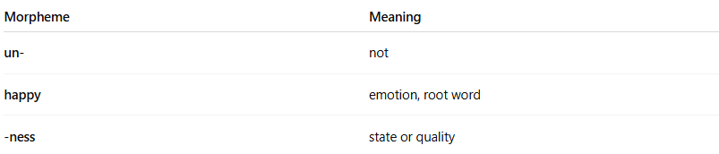
Morpheme | Meaning
un- | not
happy | emotion, root word
-ness | state or quality
✅ Each part adds to the meaning of the full word.

🧠 Types of Morphemes:
# Source: Chatgpt (GPT-4-turbo) at [7/21/2025]
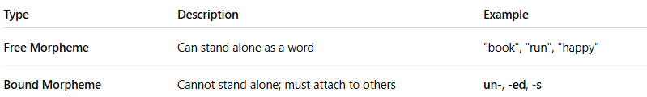
Type | Description | Example
Free Morpheme | Can stand alone as a word | "book", "run", "happy"
Bound Morpheme | Cannot stand alone; must attach to others | un-, -ed, -s

🧪 More Examples:
# Source: Chatgpt (GPT-4-turbo) at [7/21/2025]
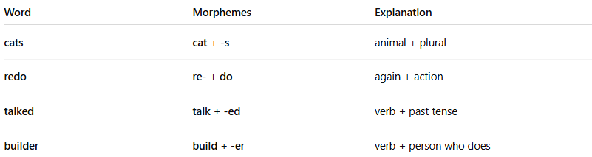
Word | Morphemes | Explanation
cats | cat + -s | animal + plural
redo | re- + do | again + action
talked | talk + -ed | verb + past tense
builder | build + -er | verb + person who does

✅ Summary:
# Source: Chatgpt (GPT-4-turbo) at [7/21/2025]
A morpheme is like a building block of meaning in language.
Words can have one morpheme (like “dog”) or many (like “unbelievable” = un + believe + able).

2-Allomorph

🧬 What is an Allomorph?
# Source: Chatgpt (GPT-4-turbo) at [7/21/2025]
An allomorph is a variation of a morpheme — a different form or pronunciation of the same morpheme that doesn't change its meaning.

📘 Definition:
# Source: Chatgpt (GPT-4-turbo) at [7/21/2025]
An allomorph is one of the different spoken or written forms a single morpheme can take, depending on its phonetic or grammatical context.

🧠 Think of it like this:
# Source: Chatgpt (GPT-4-turbo) at [7/21/2025]
Just as a phoneme can have allophones,
a morpheme can have allomorphs.

🔍 Example 1: Plural -s in English
# Source: Chatgpt (GPT-4-turbo) at [7/21/2025]
The plural morpheme “-s” has three allomorphs:
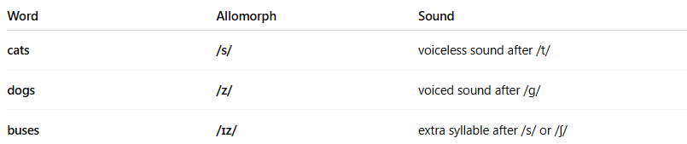

Word | Allomorph | Sound
cats | /s/ | voiceless sound after /t/
dogs | /z/ | voiced sound after /g/
buses | /ɪz/ | extra syllable after /s/ or /ʃ/
🧠 Same morpheme (= plural), but different pronunciation.

🔍 Example 2: Past Tense -ed
# Source: Chatgpt (GPT-4-turbo) at [7/21/2025]
The past tense morpheme “-ed” has 3 allomorphs:
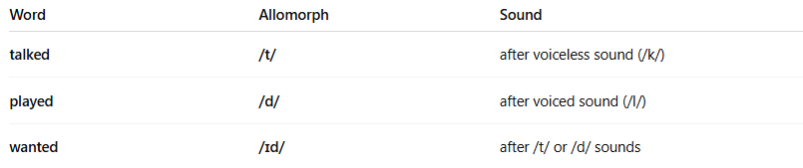
Word | Allomorph | Sound
talked | /t/ | after voiceless sound (/k/)
played | /d/ | after voiced sound (/l/)
wanted | /ɪd/ | after /t/ or /d/ sounds
Again: same meaning (past tense), different sounds.

📦 Summary:
# Source: Chatgpt (GPT-4-turbo) at [7/21/2025]
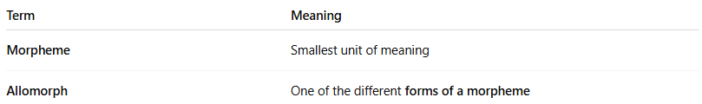
Term | Meaning
Morpheme | Smallest unit of meaning
Allomorph | One of the different forms of a morpheme

✅ Final Example:
# Source: Chatgpt (GPT-4-turbo) at [7/21/2025]
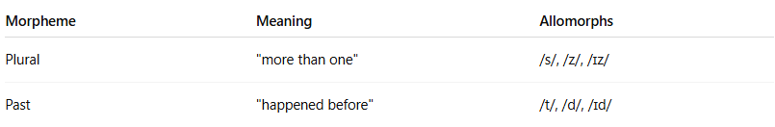
Morpheme | Meaning | Allomorphs
Plural | "more than one" | /s/, /z/, /ɪz/
Past | "happened before" | /t/, /d/, /ɪd/

